#break down total minutes played by all players

> summary(relevantAdv$MP)

Min. 1st Qu. Median Mean 3rd Qu. Max.

471 1220 1634 1582 1930 2556

**Total Minutes Played, more minutes = more opportunity for Fantasy stats

#Box plot of MP by POS

relevantAdv %>%

ggplot(aes(Pos, MP)) +

geom_boxplot()

**Total Minutes played by position; Centers are scarce in terms of playing time. One outlier PF/C who plays substantial minutes compared to others. SF and SF combos on average get the most opportunity to produce

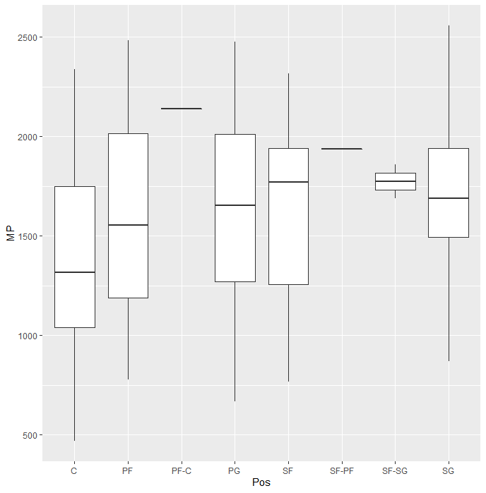

> #Box plot by POS of PER

> relevantAdv %>%

+ ggplot(aes(Pos, PER)) +

+ geom_boxplot()

**PER adjusted for per minute basis. Weighted heavily on offense. Centers on average contribute more with noted outliers at each position.

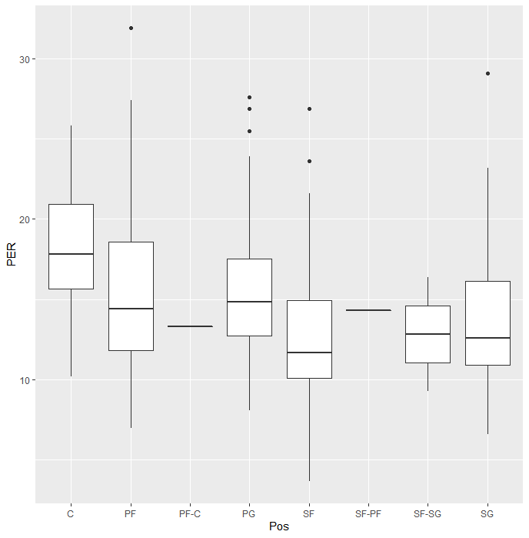

#Analyze usage rate

relevantAdv %>%

ggplot(aes(`USG%`)) +

geom_histogram(binwidth = .5, color = "black", aes(y = ..density..), fill = "gray") +

geom_density(fill = "light blue", alpha = .1, color = "blue") +

theme(panel.background = element_rect(fill = "gray95"),

panel.grid = element_blank(),

plot.background = element_rect(fill = "gray95"))

**Usage rate is the measurement of the percentage of the team’s possessions a certain player “uses” while he is on the court. Higher usage rate = more offensive opportunity

